TURKEY HILL GRANGE #1370

FINANCIAL MANAGEMENT POLICY

REFERENCES
- National Grange of the Order of the Patrons of Husbandry, Digest of Laws, 2023 Edition
- Subordinate/Community Grange Manual of the Patrons of Husbandry, 2023
- Turkey Hill Grange Bylaws, 2022

Introduction

Purpose: Provide policy and procedures for managing Turkey Hill Grange (THG) #1370 finances.

Authority: This policy is published according to THG Bylaws, Reference C, Article III, Section 2. It is authoritative on the policy, process, and procedure for managing THG finances.

Responsibilities: Financial management responsibilities of the President, Treasurer, and Executive Committee are detailed in References A, B, and C, and further explained in this policy. The THG Treasurer is responsible for this policy with the approval of the Executive Board.

Fiscal Year
Turkey Hill Grange fiscal year is 1 January through 31 December.

Funds

General Fund
The General Fund is used for ongoing business, operations, and programs. The General Fund normally is held in a checking account. Income from fundraising, donations, product sales, returns on investment, dues, and other sources is deposited in the General Fund. The Treasurer pays for goods, services, and donations from the General Fund. A General Fund savings account may be established.

Building Contingency Fund
The Building Contingency Fund is for unforeseen or emergency maintenance of the building. It normally is held in a savings account. To the extent practicable, a portion of the net outcome of fundraising and donations will be budgeted for deposit to the Building Contingency Fund.

Designated Funds
The Treasurer, with the approval of the Executive Board may set up accounts for designated purposes outside of the General Fund. The Treasurer keeps a list of Designated Funds showing:
- Name of the fund
- Purpose of the fund
- Account information
- Date of inception
- Name and contact information for the THG Member responsible for the fund
Income to a designated fund is deposited in its account. With approval of the responsible member, the Treasurer may transfer funds from a designated fund to the General Fund checking account to pay for goods, services, and donations within the scope of the designated fund. Normally, a designed fund account is closed when the purposes of the designated fund have been fulfilled. The Treasurer, with the approval of the Executive Board may close a designated fund. The remaining funds, if any, will be transferred to the General Fund.

Accounts

Types: THG money will be kept in checking, savings, or investment accounts. Checking and savings accounts must be insured by the Federal Deposit Insurance Corporation (FDIC) or National Credit Union Association (NCUA). The maximum balance in any account shall not exceed the insurance maximum limit. The Treasurer deposits cash or checks into an account in a timely manner but has discretion to hold cash or checks for up to 30 days. The Treasurer withdraws funds from THG accounts by permitted means for payment of bills, reimbursements, or other obligations.

Signatures: The Treasurer is a signatory to all THG accounts. At least one other THG Officer is a signatory on each THG account.

Electronic Banking: Accounts may be set up to allow electronic transactions. The Treasurer and at least one other Officer shall know the user identification and password for each account. Passwords shall be changed at least once each fiscal year or when a new Treasurer is installed.

Credit Card Account: The Treasurer manages an account allowing THG to accept credit card payments. Historically THG uses Square to accept credit cards.

Information Technology
The Treasurer is highly encouraged to use information technology capabilities to manage THG funds. Such capabilities allow quick and accurate funds management while supporting financial reporting and tax filing.

Investments
The Treasurer, with the approval of the Executive Board, may set up an investment account. Investment accounts must be set up with a commercial investment firm. The Treasurer recommends to the Executive Board only firms with affirmative national rankings by Forbes or similar companies. Funds will be invested with the primary purpose of conserving the principle. Investments shall support the declaration of purposes of the Grange as stated in Reference A, Chapter 2.

Donations

Donation Income: Turkey Hill Grange accepts cash, check, or credit card donations. The Treasurer will acknowledge donations by electronic mail (email) or letter.

Donation Expense: Turkey Hill Grange may donate for charitable or humanitarian purposes. Budget Line Item Numbers (LINs) may be designated for donations to Internal Revenue Service (IRS) 501(c)3 organizations or other types of charitable organizations. If a LIN is set up, the Authorized Member (see paragraph 9.1) may request the Treasurer make a check or cash donation to a specific organization. The Executive Board must approve off-budget donations.

Budget

Introduction: The budget guides fundraising and expenditures for each fiscal year. The budget is organized to show general and specific information for fundraising, operations, and programs. Line Item Numbers are assigned to each fundraising activity or type, operations area, or program; see Appendix A.

Process: The yearly THG budget is developed and approved as shown in Table 1. Figure 1 shows the budgeting process.
Table 1. Budget Schedule
Event | Schedule
Approve Budget Guidance | September Executive Board Meeting
Develop Draft Budget | October Executive Board Meeting
Approve Proposed Budget | November Executive Board Meeting
Approve Budget | November Membership Meeting

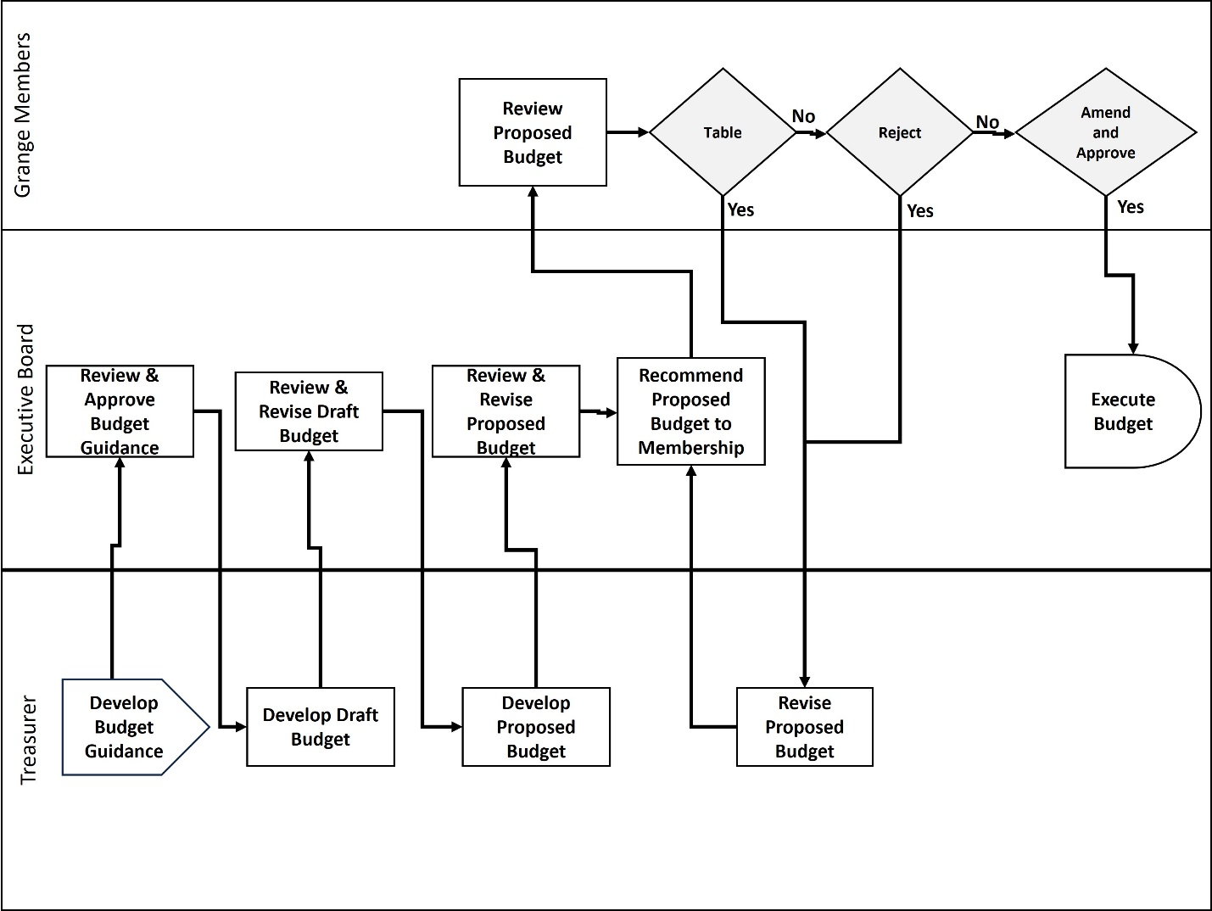
Figure 1. Budget Process
Notes:
- Budget guidance contains assumptions necessary for developing the budget.
- If tabled, the Proposed Budget must be taken from the table at the next regular meeting. If rejected, the Executive Board will revise the Proposed Budget according to member inputs and present the revised Proposed Budget at the next regular or special meeting.

Execution
Membership approval of the yearly budget is authority to execute the budget starting at the beginning of the fiscal year. Funds in THG accounts on the last day of the fiscal year are automatically carried over into the same account at the beginning of the next fiscal year. In the General Fund money is carried forward as a lump sum regardless of source.

Spending Authority
“Authorized Members” are THG Members allowed to manage funds in budget lines. Table 2 lists Authorized Members. The President may identify additional Authorized Members to the Executive Board. The authorization is effective for the entire fiscal year unless revoked.
Table 2. Authorized Members
Authorized Member | Manages Budget Lines for:
President & Vice President | Entire Budget
THG Officers | Functional areas within their responsibilities
Committee Chairperson | Committee’s functions
Project or Event Leader | Project or event
Treasurer | Recurring expenses

Contracted Expenses: Contracts for services such as lawn care become recurring expenses after the contract is completed with the service provider.

Off-Budget Expenses: Unplanned expenditures may be necessary. When an off-budget expense is identified, the President specifies an Authorized Member to manage the funds.

Over-Budget Expenses: Expenditures from a single budget line may exceed the budgeted amount. The Authorized Member manages Over-Budget expenditures in coordination with the President and Treasurer.

Contingency: Ref C provides for emergency actions. The Treasurer may use any available funds to meet short-term emergency requirements.

Reimbursement: Grange members who use their personal money to pay for Grange expenses are entitled to prompt reimbursement. Reimbursement to the Treasurer requires the approval of another Grange Officer. Appendix B describes the reimbursement process.

REPORTING

Monthly Report
The Treasurer provides a monthly report. A summary report is provided to the membership at the regular meeting. A detailed report is provided to the Executive Board allowing oversight of THG funds and accounts. The detailed report contains:
- Report of activity in each Fund.
- Detailed report of activity in each Grange account showing the date of transactions, names of the individuals or organizations to which payments were made, and the LIN to which income was credited or against which expenditures were made. (This report looks much like a traditional check register.)
- Line-by-line comparison of the budget and actual income, expenses, and outcome.
The Executive Board may request additional reports.

Federal Reporting
The Treasurer ensures Federal reporting according to IRS requirements is completed before the filing deadline. Historically THG has filed IRS form 990-N, “Postcard Return” or 990-EZ, Return of Organization Exempt from Income Tax.

State Reporting
The Treasurer ensures Illinois State reporting according to Attorney General and Secretary of State requirements are completed before the filing deadlines. Fees shall be paid to sustain THG registration with the Attorney General and Secretary of State. Historically THG has completed an Illinois Charitable Organization Annual Report, Form AG990-IL.

Tax Preparation Service
With the approval of the Executive Board, the Treasurer may contract with a tax preparation service to complete the IRS and Illinois Attorney General reporting requirements on behalf of the Grange.

- LINE ITEM Number EXAMPLES

Table A-1 Line Item Examples
Level | LIN | Category | Notes
General Heading | 1000 | PROJECTS | Summary level of detail
Project, Function, or Program Headings | 1300 | Ham & Peach Dinner | Category for specific event, operational function, or program
 | 3100 | Building
Detail Headings | 3220 | Safety & Fire Prevention | Subcategory provides additional detail
 | 3140 | Equipment & Furnishings
Detail Sub-Heading | 3141 | Sound System | Additional Subcategory for very detailed reporting

The Treasurer develops and follows a system of Line Item Numbers (LIN) to help manage funds. “Authorized Members” use LINs to help manage the projects, functional areas, and programs for which they are responsible.

- reimbursement
Grange members may use personal money to pay for goods and services for THG. Such obligations normally are made as part of a specific project, operating function, or program. The reimbursement process is designed to provide prompt and accurate payment, see Figure B-1.

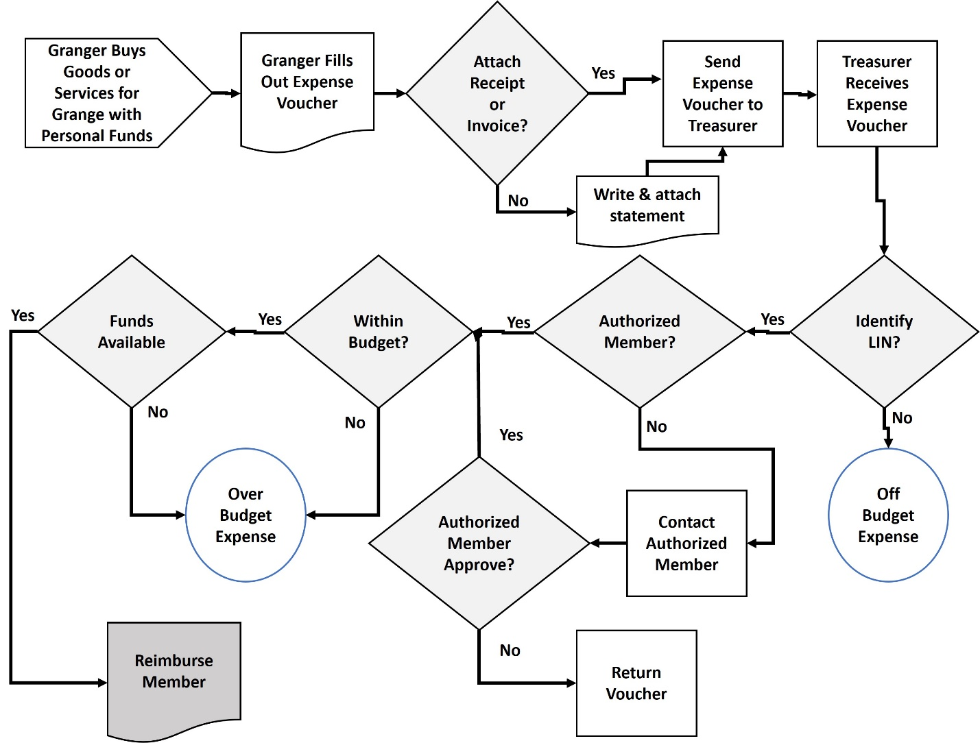
Figure B-1. Reimbursement Process
Notes
- Expense voucher: Treasurer develops an expense voucher and makes it available to THG Members in paper and electronic format. Members may send the expense voucher to the Treasurer by email, USPS mail, or placing a paper voucher in a designated location in the Grange building. If a receipt or invoice is not available, the Grange Member may write a short explanation and attach it to the expense voucher.
- Authorized Members are explained in paragraph 9.1
- Off-Budget expenses are explained in paragraph 9.1.2. Over-Budget expenses are explained in paragraph 9.1.3.

Executive Board adopted January 9, 2024

